Visit Bangladesh

An android app

**Software Requirement**

**Specification and Analysis**

**Visit Bangladesh**

**An Android App**

**Course: SE 505**

# 

# 

# 

Table of Contents

Chapter One 4

Introduction 4

1.1 **Purpose** 4

**1.2 Intended Audience** 5

Chapter Two 6

Inception 6

**2.1 Introduction** 6

**2.2 Conclusion** 7

Chapter Three 8

Elicitation 8

**3.1 Introduction** 8

**3.2 Eliciting requirements** 8

**3.3 Requirements gathering** 9

**3.4 Quality function deployment** 9

**3.5 User scenario** 10

**3.6 Elicitation work product** 10

Chapter Four 12

Scenario Based Model 12

**4.1 Introduction** 12

**4.2 Use case diagram** 12

4.2 Use Case Scenario 13

Figure 1: Level 0 Use Case Diagram 14

Figure 2: Level 1 Use Case Diagram 15

Figure 3: Level 1.1 Use Case Diagram of Authentication Subsystem 16

Figure 4: Level 2.2 Use Case Diagram of Group Creation Subsystem 17

Figure 5: Level 2.3 Use Case Diagram of Search Subsystem 18

Figure 6: Level 1.3 Use Case Diagram of View Subsystem 20

Figure 7: Level 1.4 Use Case Diagram of Settings Subsystem 20

**4.3 Activity Diagrams of Camera Synchronization** 21

Figure 9: Level 4.3.1 Activity Diagram of Sign Up 23

Figure 10: Level 4.3.2 Activity Diagram of Sign In 24

Figure 10: Level 4.3.2 Activity Diagram of An-authentic 25

Figure 11: Level 4.3.3 Activity Diagram of Sign out 26

Figure 12: Level 4.3.4 Activity Diagram of Send Request 28

Figure 13: Level 4.3.4 Activity Diagram of Cancel Request 30

Figure 14: Level 4.3.5 Activity Diagram of Accept Request 31

Figure 15: Level 4.3.4 Activity Diagram of Remove from group 33

Figure 16: Level 4.3.4 Activity Diagram of profile view 34

Figure 17: Level 4.3.4 Activity Diagram of Camera View 36

Figure 18: Level 4.3.4 Activity Diagram of Change profile photo 38

Figure 18: Level 4.3.4 Activity Diagram of Change user name 40

4.4 Swim-lane diagram of Camera Synchronization 40

4.4.1 Swim-lane diagram of Sign Up 40

4.4.2 Swim-lane diagram of Sign In 42

4.4.3 Swim-lane diagram of Un-authentic 43

4.4.4 Swim-lane diagram of Sign out 44

4.4.5 Swim-lane diagram of Send Request 45

4.4.7 Swim-lane diagram of Cancel Request 46

4.4.8 Swim-lane diagram of Accept Request 47

4.4.9 Swim-lane diagram of Remove from group 48

4.4.10 Swim-lane diagram of Profile View 50

4.4.11 Swim-lane diagram of Camera View 51

4.4.12 Swim-lane diagram of Change profile photo 52

4.4.13 Swim-lane diagram of Change User name 53

**Chapter Five** 54

**Data Model** 54

5.1 Introduction 54

5.2 Data object 54

5.3 ER diagram 58

5.4 Data schema table 59

**Chapter Six** 61

**Class Based Model Of Camera Synchronization Android Application** 61

6.1 Grammatical Parsing and Analysis 61

6.1.1 CLASS IDENTIFICATION WITH GENERAL CLASSIFICATION 61

6.1.2 CLASS IDENTIFIED WITH SELECTION CRITERIA 64

6.2.1 Attributes and Methods of Preliminary Classes 67

6.2.2 Analysis on potential classes: 68

6.2.3 Final Classes 68

6.3 Class Responsibility Collaborator modeling 71

6.3.1 Class cards 71

6.3.2 UML Diagram 73

BEHAVIORAL MODEL OF ‘CAMERA  SYNCHRONIZATION’ A MOBILE  APPLICATION 74

7.1 State diagram of  User : 74

7.2 State diagram of  Member: 75

7.3  State diagram of  Gallery: 75

7.4  State diagram of  System: 76

7.5  State diagram of  Database: 77

DATA FLOW MODEL OF ‘CAMERA SYNCHRONIZATION’ A MOBILE  APPLICATION 78

8.1.1 level 1: 79

8.1.2: Level 2.1 80

8.2.1 Level 2.2.1 81

8.2.1 Level 2.2.2 82

8.2.1 Level 2.3 83

8.2.1 Level 2.4 84

8.2 Sequence diagram 84

# **Chapter Five**

## **Data Model**

### 5.1 Introduction

A data model is a conceptual representation of data structures (tables) required for a database and is very powerful in expressing and communicating the business requirements. In this chapter, we will discuss about the data model for Visit Bangladesh.

### 5.2 Data object

A data object is a representation of information which has different properties or attributes that must be understood by software. We have found the following data objects in Visit Bangladesh:

#### 5.2.1 Noun Identify

Nouns are identified from the usage scenario and shown in the table below:

**Table 1: Identifying Potential Data Objects**

|  |  |  |  |
| --- | --- | --- | --- |
| **No.** | **Noun/Noun Phrases** | **Problem Domain/Solution Domain** | **Attributes** |
| **1.** | Authentication | S |  |
| **2.** | System | P | 11,12,25,34 |
| **3.** | Guest User | S |  |
| **4.** | User | P |  |
| **5.** | Username | S | 4 |
| **6.** | Id | S | 4,31,35,36,37,20,38, |
| **7.** | Password | S | 4 |
| **8.** | Account | P | 2 |
| **9.** | Nearest Place | S |  |
| **10.** | Information | S | 39,37,36, |
| **11.** | Sign in | S |  |
| **12.** | Sign out | S |  |
| **13.** | Place Image | P |  |
| **14.** | Place Name | P |  |
| **15.** | Travel Agency | S | 36 |
| **16.** | Route | P |  |
| **17.** | Profile | P | 4 |
| **18.** | Search | P |  |
| **19.** | Location | S | 36,38 |
| **20.** | Division | P |  |
| **21.** | Address | S | 36,38,37 |
| **22.** | Comment | S |  |
| **23.** | Emergency Contract | S |  |
| **24.** | Edit Account | P |  |
| **25.** | Send Notification | S |  |
| **26.** | Profile photo | S | 4 |
| **27.** | Settings | S |  |
| **28.** | Database | P |  |
| **29.** | Edit Profile | P |  |
| **30.** | Remove | S |  |
| **31.** | Email | S |  |
| **32.** | Phone | S | 4,35,38 |
| **33.** | Date | P |  |
| **34.** | Update Location | P |  |
| **35.** | Guide | S |  |
| **36.** | Tourist place | S |  |
| **37.** | City | S |  |
| **38.** | Police Station | S |  |
| **39.** | Add | P |  |

#### 5.2.2 Prospective Data Objects:

**User:**  Id, Username, Password, Email, Phone,

**Location:** Division name, Description, Photo

**City:** name, Description

**Tourist Place:** Place Photos, Name, Description, Comment

**Add Tourist Place:** Place Photos, Name, Description

**Location type:** Mountain, sea area, Fount, Forestland

**Bus route:** route details

**Air route:** route details

**Ship route:** route details

#### 5.2.3 Analysis on Prospective Data Objects:

Bus route, Air and Ship have same attributes. So we can merge them into Route.

Add Tourist Place and Tourist place have same attributes. So we can merge them into Tourist Place.

#### 5.2.4 Actual Data Objects

**User:**  Id, Username, Password, Email, Phone, Emergency Contract

**Location:** Division name, Description, Photo

**City:** name, Description

**Tourist Place:** Place Photos, Name, Description, Comment

**Location type:** Mountain, sea area, Fount, Forestland

**route:** route details, Way

#### 5.2.5 Relationship among Data Objects

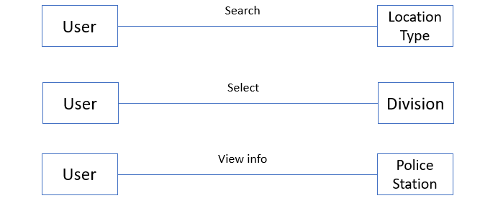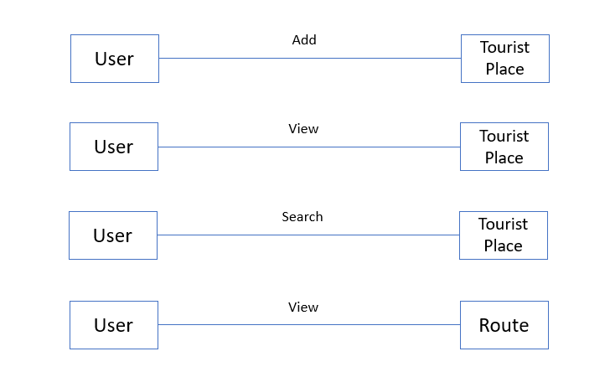

**Figure : Relationship among Data Objects**

### 5.3 ER diagram

Based on the data objects found, in order to show the relationship among the data objects, ER diagram that is Entity-Relationship Diagram is used widely. Here, the ER Diagram based on the data objects of Visit Bangladesh is shown below.

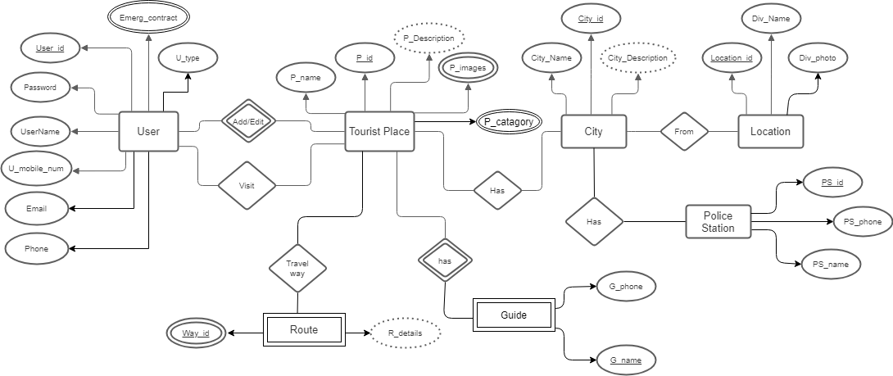

**Figure : Entity Relationship Diagram**

### 5.4 Data schema table

Based on the data objects, the following data schema tables can be created:

**Table : User**

|  |  |  |
| --- | --- | --- |
| **Attribute** | **Type** | **Size** |
| User Id | Varchar | 20 |
| User Name | Varchar | 20 |
| Emergency Contract | Number | 20 |
| Password | Varchar | 20 |
| Email | Varchar | 10 |
| Phone | Number | 10 |

**Table : Tourist Place**

|  |  |  |
| --- | --- | --- |
| **Attribute** | **Type** | **Size** |
| Place Name | Varchar | 20 |
| Description | Varchar | 300 |
| Place Images | LongBlob | 5 |
| City Id | Number | 20 |

**Table : City**

|  |  |  |
| --- | --- | --- |
| **Attribute** | **Type** | **Size** |
| City Id | Varchar | 10 |
| City Name | Varchar | 10 |
| City Description | Varchar | 50 |

**Table : Location**

|  |  |  |
| --- | --- | --- |
| **Attribute** | **Type** | **Size** |
| Division Name | Varchar | 20 |
| Division Photo | LongBlob | 10 |
| Location Id | Varchar | 10 |

**Table : Guide**

|  |  |  |
| --- | --- | --- |
| **Attribute** | **Type** | **Size** |
| Guide Id | Varchar | 20 |
| Guide Name | Varchar | 10 |
| Guide Phone | Number | 11 |

**Table : Police Station**

|  |  |  |
| --- | --- | --- |
| **Attribute** | **Type** | **Size** |
| PS Id | Varchar | 20 |
| PS Name | Varchar | 10 |
| PS Phone | Number | 11 |

**Table : Tourist Location Type**

|  |  |  |
| --- | --- | --- |
| **Attribute** | **Type** | **Size** |
| Type Id | Varchar | 20 |
| Type Name | Varchar | 10 |

**Table : Route**

|  |  |  |
| --- | --- | --- |
| **Attribute** | **Type** | **Size** |
| Way Id | Varchar | 20 |
| Route Details | Varchar | 300 |

# **Chapter Six**

## **Class Based Model Of Visit Bangladesh Android Application**

Class-based modeling represents the objects that the system will manipulate, the operations that will apply to the objects, relationships between the objects and the collaborations that occur between the classes that are defined.

# 6.1 Grammatical Parsing and Analysis

To identify our analysis class, firstly, we grammatically parsed all the nouns and then categorized them according to general classification and selection criteria. We identified potential class by identifying the nouns from the scenery. Then we compared those with the following criteria whether they matched or not. We noted down the number of the fulfilled criteria at the right column.

### 6.1.1 CLASS IDENTIFICATION WITH GENERAL CLASSIFICATION

In table 7, the nouns from the usage scenario are classified by general classification. Also, here, by “P” we meant a noun is in problem domain and by “S” we meant solution space.

**General Classification:**

1. External entities

2. Things

3. Occurrence or events

4. Roles

5. Organizational unit

6. Places

7. Structure

These criteria are used to find Potential Classes in following table-

**Table :  Class Identification with General Classification**

|  |  |  |  |
| --- | --- | --- | --- |
| **No.** | **Noun or Noun Phrases** | **P/S** | **General Classification**  **(GC)** |
| **1.** | Authentication | S | 3,5 |
| **2.** | System | P | 4,5 |
| **3.** | Guest User | S | 4 |
| **4.** | User | P | 4,5,7 |
| **5.** | Username | S | 2 |
| **6.** | Id | S | 2 |
| **7.** | Password | S | 2 |
| **8.** | Account | P | 4,5 |
| **9.** | Nearest Place | S | 4 |
| **10.** | Information | S | 2 |
| **11.** | Sign in | S | 3 |
| **12.** | Sign out | S | 3 |
| **13.** | Place Image | P |  |
| **14.** | Place Name | P |  |
| **15.** | Travel Agency | S | 5 |
| **16.** | Route | P |  |
| **17.** | Profile | P | 2 |
| **18.** | Search | P |  |
| **19.** | Location | S | 2 |
| **20.** | Division | P | 6 |
| **21.** | Address | S | 6 |
| **22.** | Comment | S | 2 |
| **23.** | Emergency Contract | S | 2 |
| **24.** | Edit Account | P |  |
| **25.** | Send Notification | S | 2,3 |
| **26.** | Profile photo | S | 2 |
| **27.** | Settings | S |  |
| **28.** | Database | P | 2 |
| **29.** | Edit Profile | P | 2 |
| **30.** | Remove | S |  |
| **31.** | Email | S |  |
| **32.** | Phone | S |  |
| **33.** | Date | P | 2 |
| **34.** | Update Location | P | 3 |
| **35.** | Guide | S | 4,5 |
| **36.** | Tourist place | S | 6 |
| **37.** | City | S | 6 |
| **38.** | Police Station | S | 5,6 |
| **39.** | Add | P | 3 |

### 6.1.2 CLASS IDENTIFIED WITH SELECTION CRITERIA

The nouns having two or more than two were selected from the general classification list. After that step, we compared them with the following criteria list. Those are

1. Retained information

2. Needed services

3. Multiple attributes

4. Common attributes

5. Common operations

6. Essential requirements

In table , with the help selection criteria we identified whether the noun is accepted for preliminary class or not**.**

**Table :  Class Identification with Selection Criteria**

|  |  |  |
| --- | --- | --- |
| **No.** | **Noun** | **Special Classification (SC)**  **Accepted** |
| **1.** | Authentication |  |
| **2.** | System | 1,2,3 |
| **3.** | Guest User |  |
| **4.** | User | 1,2,3,4,5 |
| **5.** | Username |  |
| **6.** | Id |  |
| **7.** | Password |  |
| **8.** | Account | 1,2,3 |
| **9.** | Nearest Place | 1,2,6 |
| **10.** | Information | 1 |
| **11.** | Sign in |  |
| **12.** | Sign out |  |
| **13.** | Place Image | 2,1,3 |
| **14.** | Place Name | 1 |
| **15.** | Travel Agency |  |
| **16.** | Route |  |
| **17.** | Profile | 4,3 |
| **18.** | Search | 1,2,3 |
| **19.** | Location | 2,3,4,5 |
| **20.** | Division | 3,4,2,5 |
| **21.** | Address |  |
| **22.** | Comment |  |
| **23.** | Emergency Contract |  |
| **24.** | Edit Account |  |
| **25.** | Notification | 2,3,4,6 |
| **26.** | Profile photo |  |
| **27.** | Settings | 2 |
| **28.** | Database | 1,2,6 |
| **29.** | Edit Profile |  |
| **30.** | Remove |  |
| **31.** | Email |  |
| **32.** | Phone |  |
| **33.** | Date |  |
| **34.** | Update Location | 2, |
| **35.** | Guide |  |
| **36.** | Tourist place |  |
| **37.** | City |  |
| **38.** | Police Station |  |
| **39.** | Admin | 1,2,3,4,5 |
| **40.** | Add |  |

### 6.2.1 Attributes and Methods of Potential Classes

Analyzing the above table, we have categorized the verbs and convert them into method names. We put them to their respective classes and showed them in the table :

**Table :Potential Classes after General and Selection Criteria**

|  |  |  |
| --- | --- | --- |
| **Potential Class** | **Nouns** | **Verb** |
| Account | Verification code, User | Log in, Sign up, log out, send Verification code |
| User | User Id, Name, Email Profile photo, Phone number | Requires an account, can log in to the system, receives message, search, update user information, recover his/her password, add place information, add comment |
| Admin | Place, Member | Can edit places, can add places, can remove member, can remove comments |
| System | User, Places | Show popular Place(s), show viewing options,  show searched items, can generate SMS and send  SMS, sent emergency notification. |
| Notification | User Id, receiver, type | Will be generated and sent |
| Search | User, City, Place, Keyword, | Search by keyword, search by popular, search location type wise, search recommended, search by Police Station, search by place and City |
| Database | User, product | Update, retrieve, stored, removed |
| Location | Id, Division Name, Division photo | Division Name, Division photo are visiting by users. |
| City | Id, city name, City Description, Police Station Name, Police Station details, Police station Name | city name, City Description, Police Station Name, Police Station details, Police station Name are Visiting by Users |
| Tour Place | Id, Place Name, Type, Photo, Place Details, Guide name, Guide number, Route Details, Route type | Place Name, Type, Photo, Place Details, Guide name, Guide number, Route Details, Route type are update by users and admin |

## 6.2.3 Attribute Selection

**Table :** **Attribute Selection of Classes**

|  |  |
| --- | --- |
| **Potential Class** | **Noun** |
| Account | Verification code  User |
| User | User Id  Name  Email  Profile photo  Phone number  Emergency Contracts |
| Admin | Place  Member |
| System | User  Places |
| Notification | User Id  receiver  type |
| Search | User  City  Place  Keyword |
| Database | User  Place |
| Location | Id  Division Name  Division Photo |
| City | Id  City Name  City Description  Police station Id  Police station name  Police station number |
| Tour Place | Id  Place Name  Place Type  Place Photos  Place Description  Place route  route Details  Guide name  Guide Phone |

## 

## 6.2.3 Method Identification:

**Table : Methods of Class**

|  |  |  |
| --- | --- | --- |
| **No.** | **Class** | **Methods** |
| 1 | Account | * signUp() * login() * signOut() * lockAccount() * sendVerificationCode() * recoverPassword() * verifyEmail() * verifyUser() * manageForgotPassword() * storeAuthenticationInfo() |
| 2 | User | * setUserID() * getUserID () * setName() * getName() * setEmail() * getEmail() * setPhoneNo() * getPhoneNo() * setEmergencyContractNo() * getEmergencyContractNo () * addPlace() * Emergency() |
| 3 | Admin | * addPlace() * removePlace() * editPlace() * editProfile() |
| 4 | System | * viewOptions() * showSearchedItem() * generateSMS() * sendSMS() * setConnection() |
| 5 | Notification | * setNotificationID() * getNotificationID() * getSender() * setSender() * setReceiver() * getReceiver() * getDescription() * setDescription() * sendNotification() * generateNotification() |
| 6 | Search | * searchbyCity() * searchbyPlace() * searchbykeywords() * searchPopular() * searchTypewise() * searchRecommended() |
| 7 | Database | * insertInfo() * updateInfo() * deleteInfo() * retrieveInfo() |
| 8 | Location | * getLocationID() * setLocationID() * getDivisionName() * setDivisionName () * getDivisionPhoto() * setDivisionPhoto () |
| 9 | City | * getCityID() * setCityID() * getCityName() * setCityName() * getCityDetails() * setCityDetails() * getPoliceStationID() * setPoliceStationID() * getPoliceStationName() * setPoliceStationName() * getPoliceStationDetails() * setPoliceStationDetails() |
| 10 | Tour Place | * getTourPlaceID() * setTourPlaceID() * getTourPlaceName() * setTourPlaceName() * getTourPlaceImages() * setTourPlaceImages() * getTourPlaceDescription() * setTourPlaceDescription() * getRoute() * setRoute() * getRouteDetails() * setRouteDetails () * getGuideName() * setGuideName() * getGuideNumber() * setGuideNumber() |

## 6.2.4 Finalizing Classes

To identify the final classes, it was required to check if there can be any hierarchies, merges, additional attributes, methods or classes. These identifications are given below:

* + 1. There are two types of users in the system. So the alluser class could be the parent class of the admin class and user class. But, as the user class and the admin class has different attributes and methods there is no need of alluser class.

System and User classes will have an additional method (viewOptions()) so that it can be used to get to other methods

## 6.3 Class Responsibility Collaborator modeling

CRC modeling stands for Class Responsibility Collaboration modeling. CRC modeling includes class cards and CRC diagram.

### 6.3.1 Class cards

Class cards show attributes, methods and collaborating class names along with their responsibility. A responsibility comprises one or more methods together. The potential classes for the system are- Account, User, Admin,System, Notification, Search, Database, Location, City, Tour Place. The proposed class cards of these classes are shown below.

**Table : Account Class Card**

|  |  |
| --- | --- |
| **Responsibility** | **Collaborators** |
| Receiving information for registration | System |
| Checking availability of user and Admin Id | System |
| Receiving id and password |  |
| Creating Account | Database |
| Verifying login | System |

**Table : User Class Card**

|  |  |
| --- | --- |
| **Responsibility** | **Collaborators** |
| Authentication | Account |
| Add Place Info | Database |
| View Places | Location |
| Request Emergency | System |

**Table 22: Admin**

|  |  |
| --- | --- |
| **Responsibility** | **Collaborators** |
| Authentication | Account |
| Add Place Info | Location |
| View Places | Location |
| Edit Place Info | Location |

**Table 23: System**

|  |  |
| --- | --- |
| **Responsibility** | **Collaborators** |
| Get searched Items | Search |
| Generate Notifications | Notification |
| Generate Emergency Message | Notification |
|  |  |

**Table : Notification**

|  |  |
| --- | --- |
| **Responsibility** | **Collaborators** |
| Gets Notification | User |
| Generate Notifications | System |

**Table : Search Card**

|  |  |
| --- | --- |
| **Responsibility** | **Collaborators** |
| Generating Search | System |
| Search for Tour Place | Location |
| Search for City | Location |

**Table : Database Card**

|  |  |
| --- | --- |
| **Responsibility** | **Collaborators** |
| Store Admin Info | Admin |
| Store User Info | User |
| Store/Update Tour Place City | Location |

**Table : Location Card**

|  |  |
| --- | --- |
| **Responsibility** | **Collaborators** |
| Store/Update Tour Place City | Database |
| Search for Tour Place | Search |
| View Tour Place | Admin/User |

**Table : City Card**

|  |  |
| --- | --- |
| **Responsibility** | **Collaborators** |
| Update/View city Information | Location |

**Table : Tour Place Card**

|  |  |
| --- | --- |
| **Responsibility** | **Collaborators** |
| Update/View Tour Place Information | Location |

### 6.3.2 UML Diagram

#### 

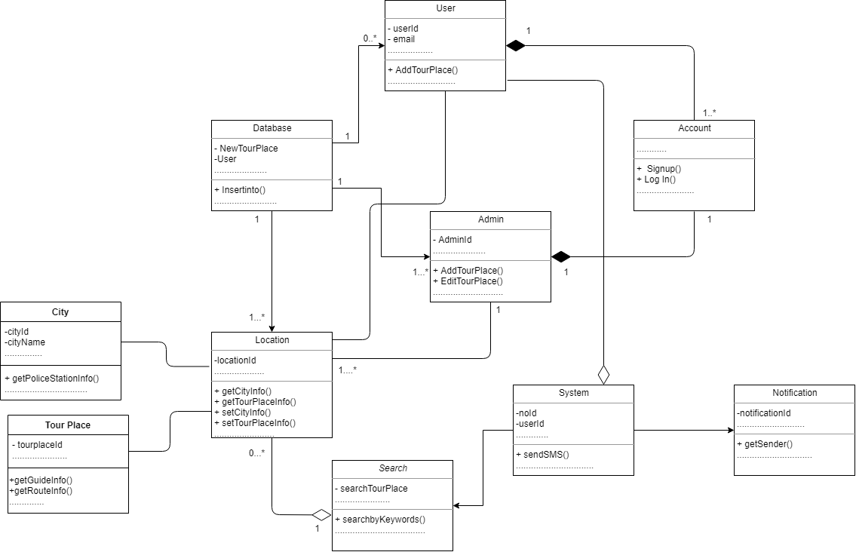

**CHAPTER 7**

## BEHAVIORAL MODEL OF ‘CAMERA  SYNCHRONIZATION’ A MOBILE  APPLICATION

The behavioral model indicates how software will respond to external events. There are two different behavioral representations. The first indicates how individual class changes state based on external events and the second shows the behavior of the software as a function of time. State diagram shows the state in a module of an user. State diagram of this project are following:

### 7.1 State diagram of  User :

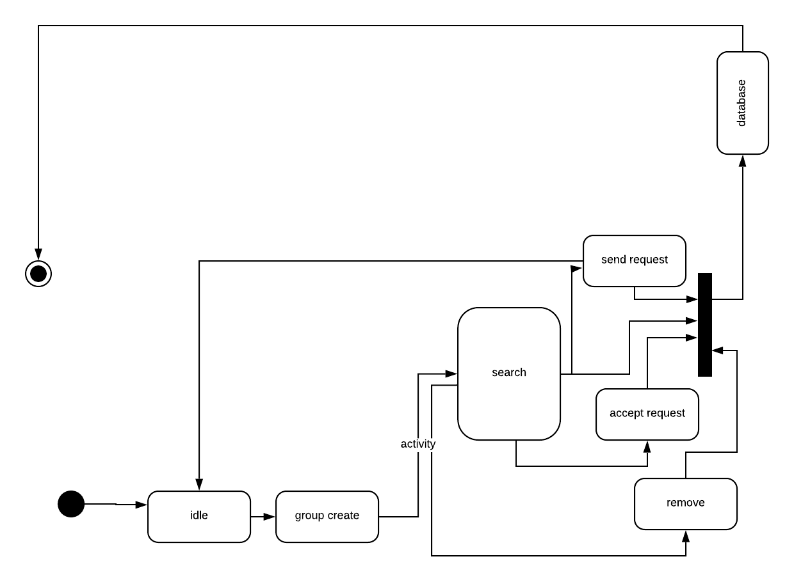

### 7.2 State diagram of  Member:

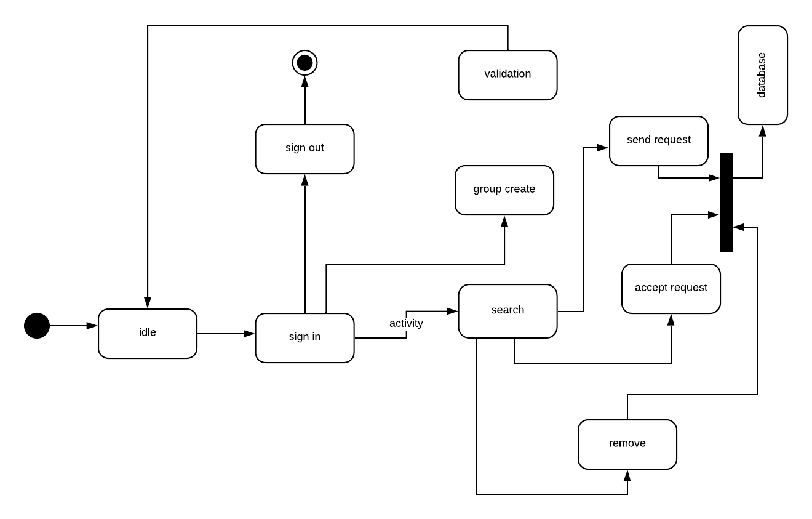

### 7.3  State diagram of  Gallery:

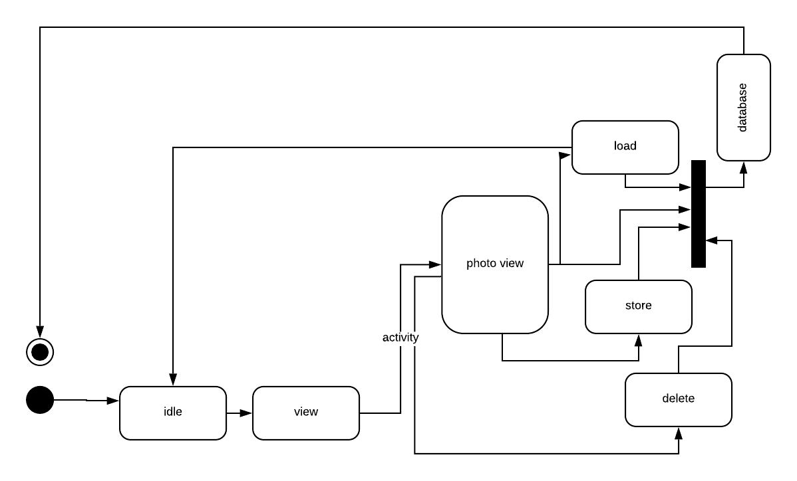

### 7.4  State diagram of  System:

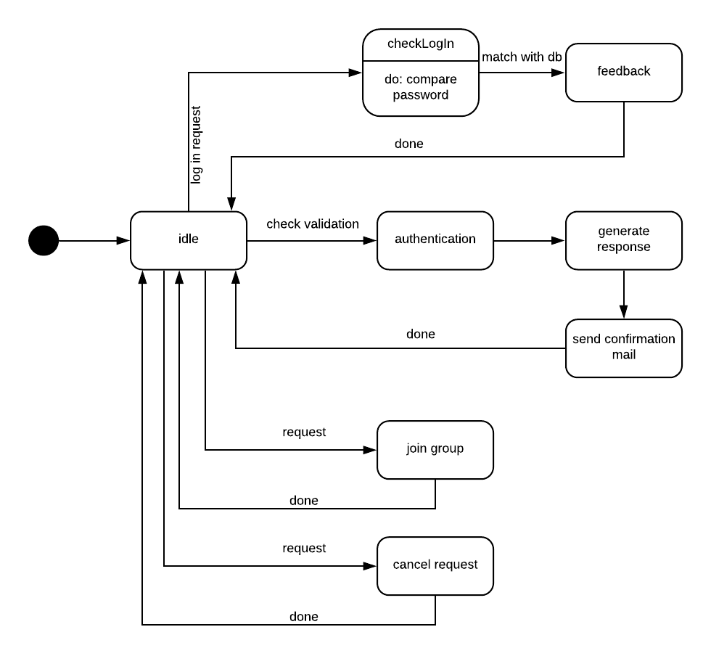

### 7.5  State diagram of  Database:

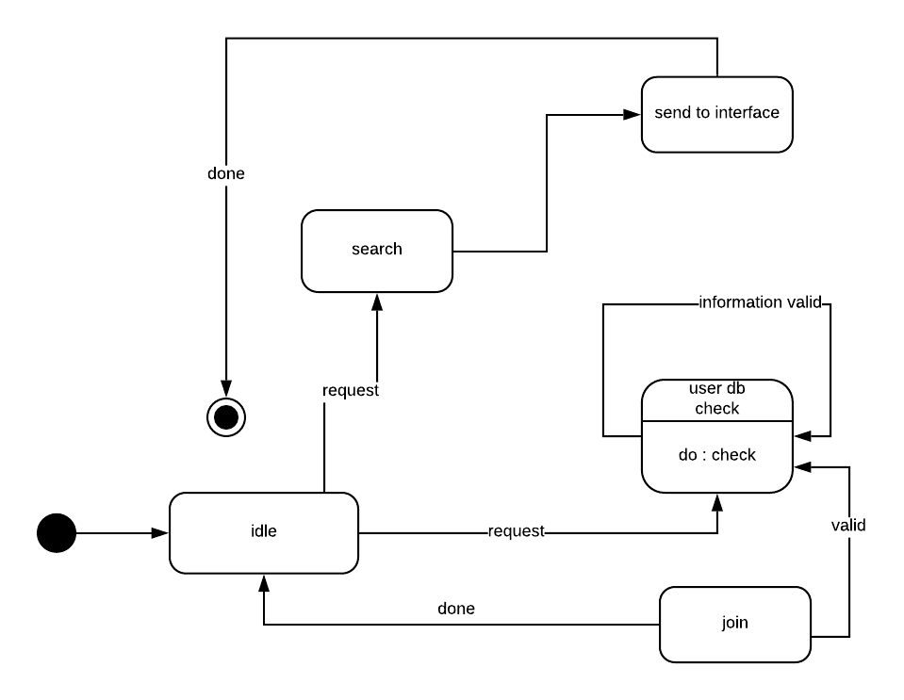

**CHAPTER 8**

## DATA FLOW MODEL OF ‘CAMERA SYNCHRONIZATION’ A MOBILE  APPLICATION

A data flow model is a representation of the flow and exchange of information within a system. Data flow models are used to graphically represent the flow of data in an information system by describing the processes involved in transferring data from input to file storage and reports generation. A data flow model may also be known as a data flow diagram (DFD). Data flow modeling can be used to identify a variety of different things, such as:

* Information that is received from or sent to other individuals, organizations, or other computer systems.
* Areas within a system where information is stored and the flows of information within the system are being modeled.
* The processes of a system that act upon information received and produce the resulting outputs.

Data Flow Diagrams of “Camera synchronization” is given below:

## 8.1.1 level 1:

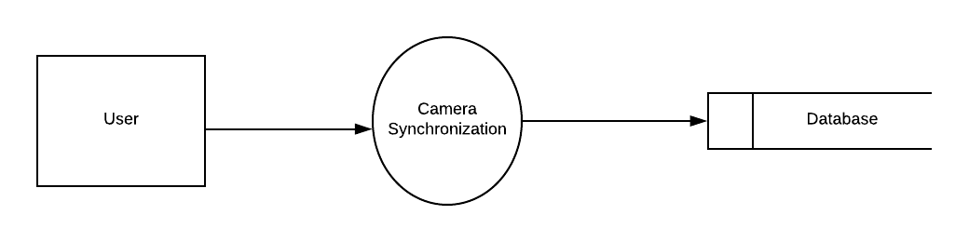

#### Figure 1: level 1 for Camera Synchronization

## 8.1.2: Level 2.1

#### https://lh6.googleusercontent.com/iqV1r44Q16LxUy5n1xNq7PHB533MjrP9XUDjqqhNIUTc_yH8957QfnUE6L7ehOp9_uCArbbGCIMzKAVGPK6yZyNyv8u6Xk8qK4WPm_RGBjMsP0NW77YZJ3oFflCVPm3pAoTZC8VCFigure 2: level 2.1 for Camera Synchronization

## 8.2.1 Level 2.2.1

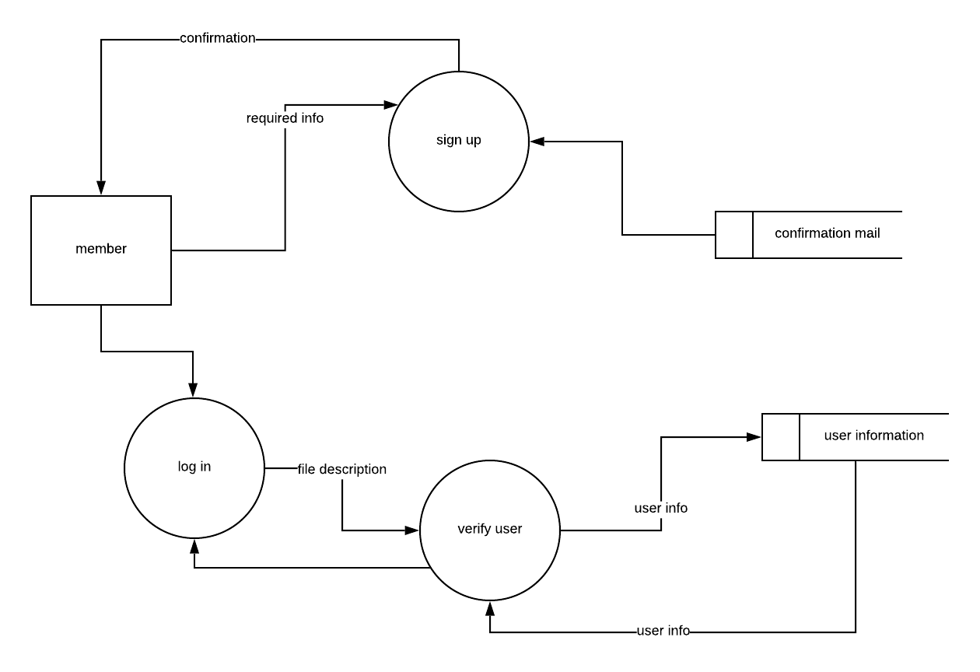

#### Figure 3: level 2.2.1 for Camera Synchronization

## 8.2.1 Level 2.2.2

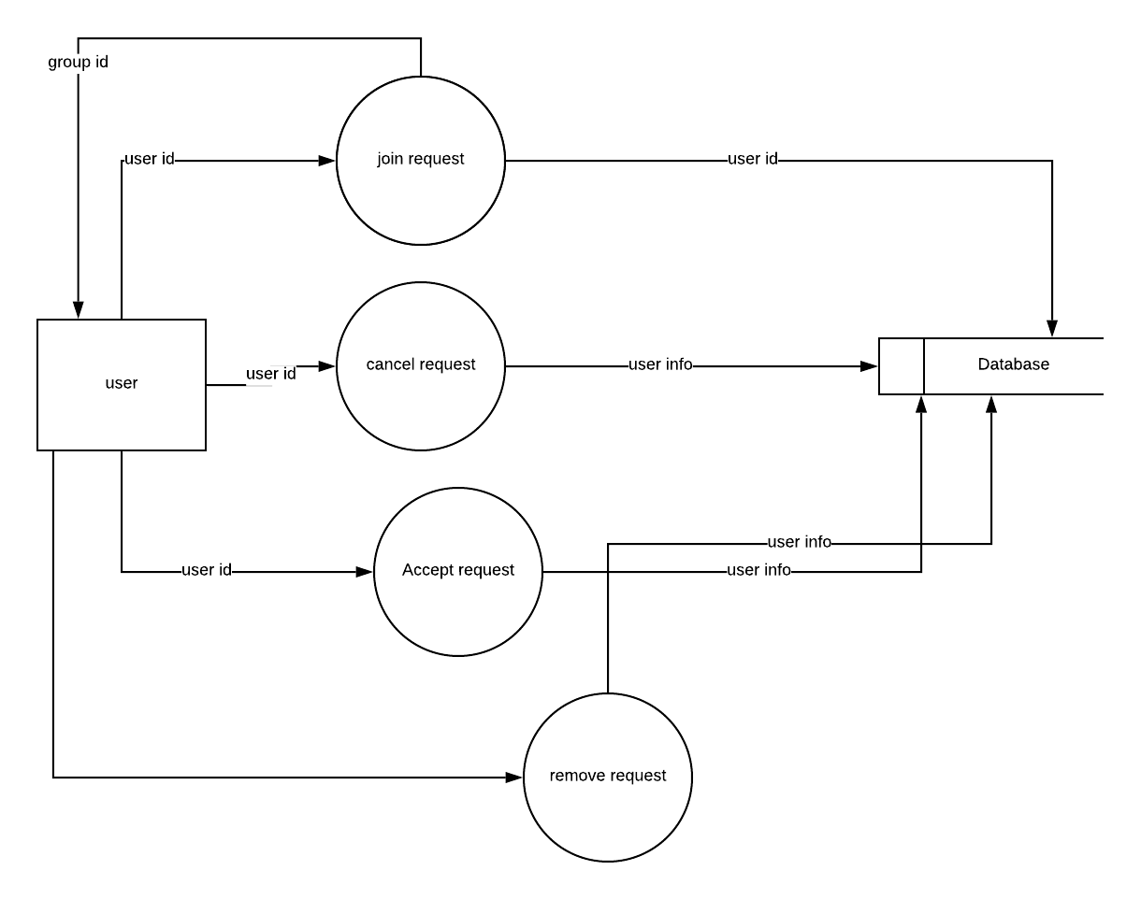

#### Figure 4: level 2.2.2. for Camera Synchronization

### 8.2.1 Level 2.3

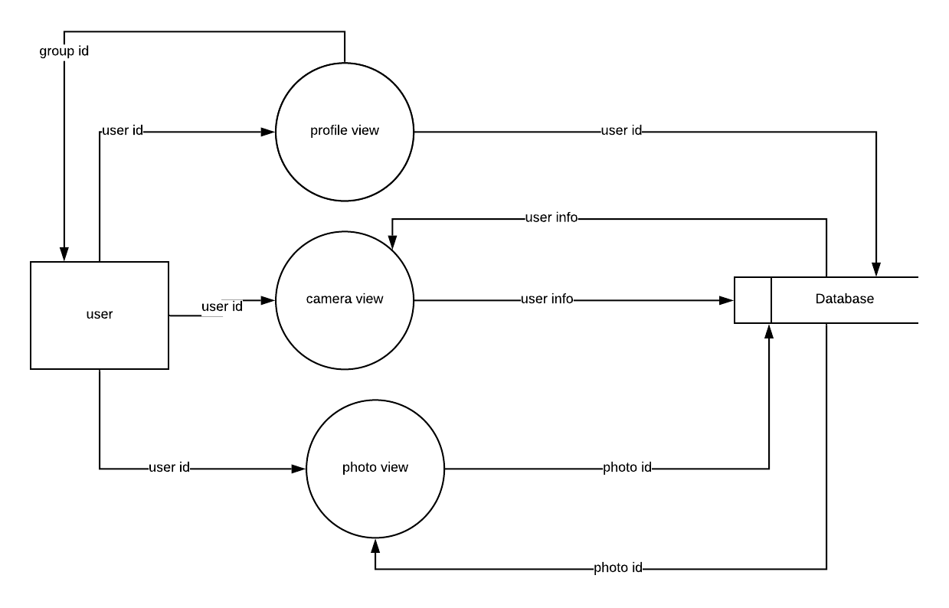

#### Figure 5: level 2.3 for Camera Synchronization

### 8.2.1 Level 2.4

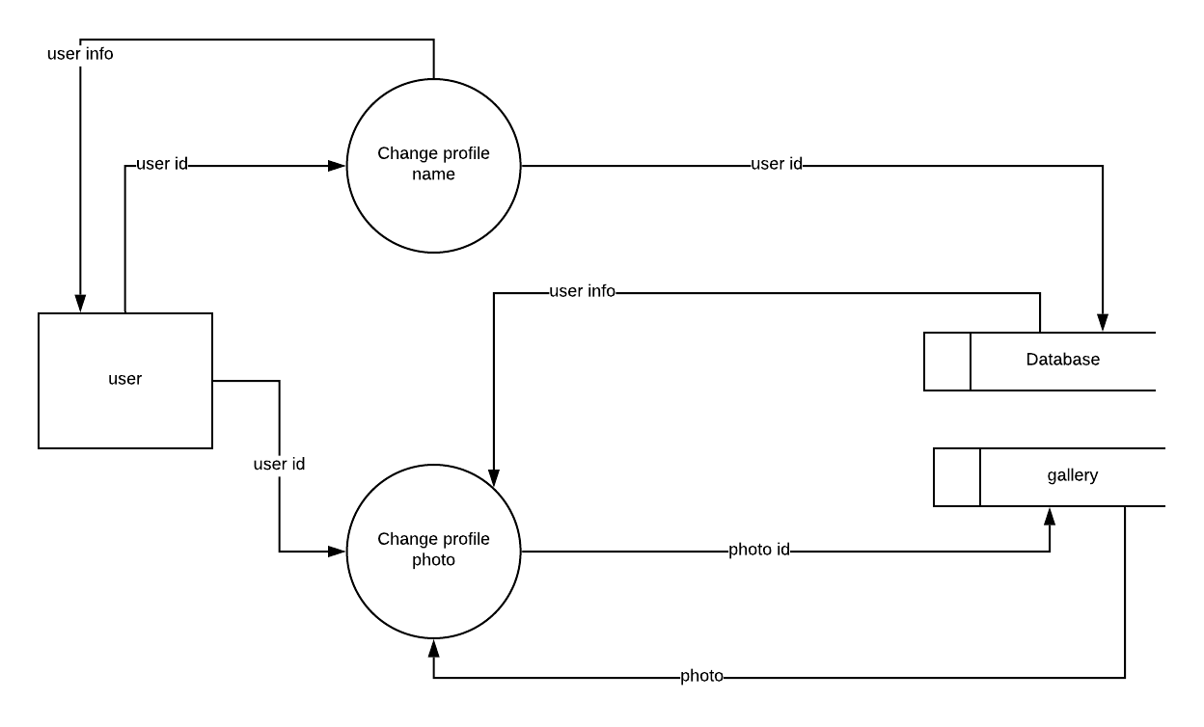

#### Figure 6: level 2.5 for Camera Synchronization

## 8.2 Sequence diagram

A sequence diagram is an interaction diagram that shows how objects operate with one another and in what order. It is a construct of a message sequence chart. A sequence diagram shows object interactions arranged in time sequence. We have shown the sequence diagram of three modules- Homepage, personal account and administration.

#### 8.2.1 Sequence diagram of Sign Up

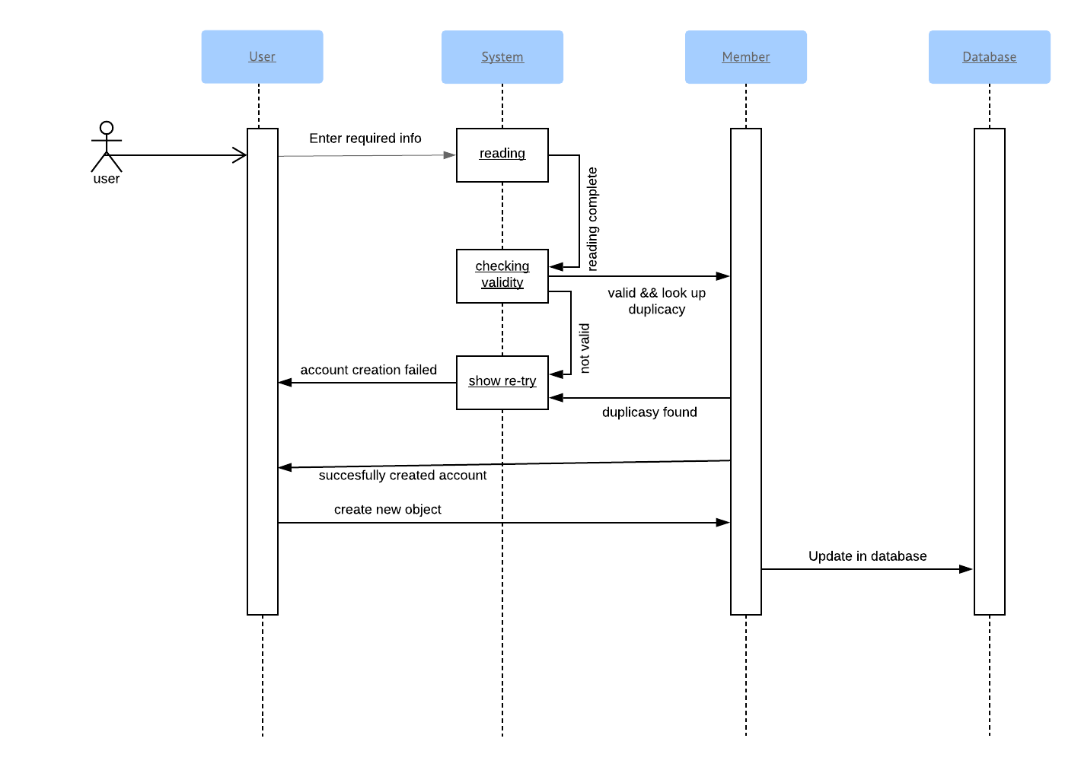

#### 

#### 8.2.2 Sequence diagram of Sign In

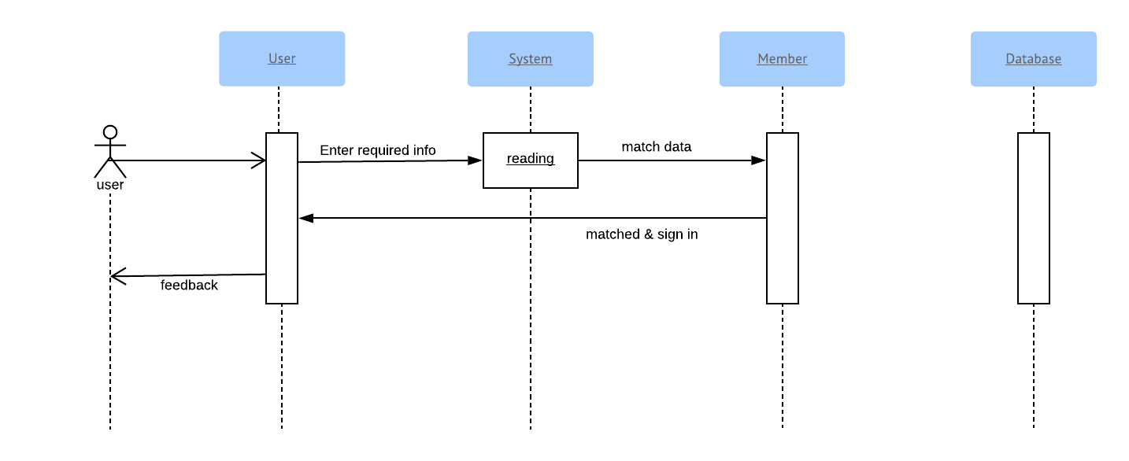

#### 8.2.3 Sequence diagram of Sign Out

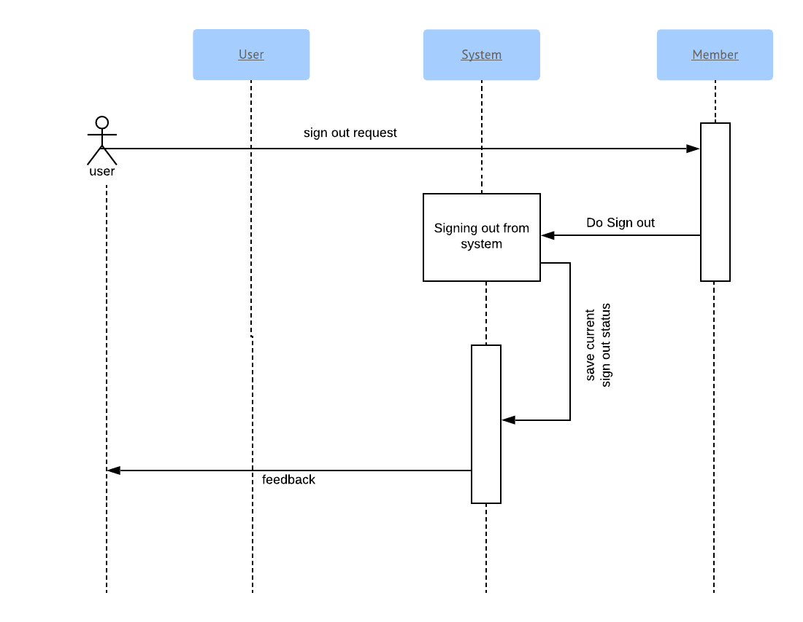

#### 8.2.4 Sequence diagram of Search

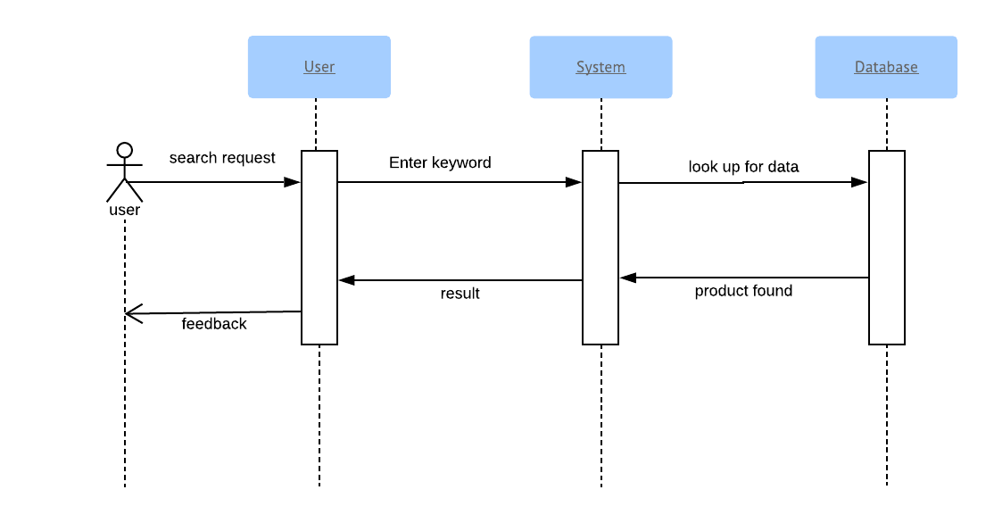

#### 8.2.5 Sequence diagram of Save photo

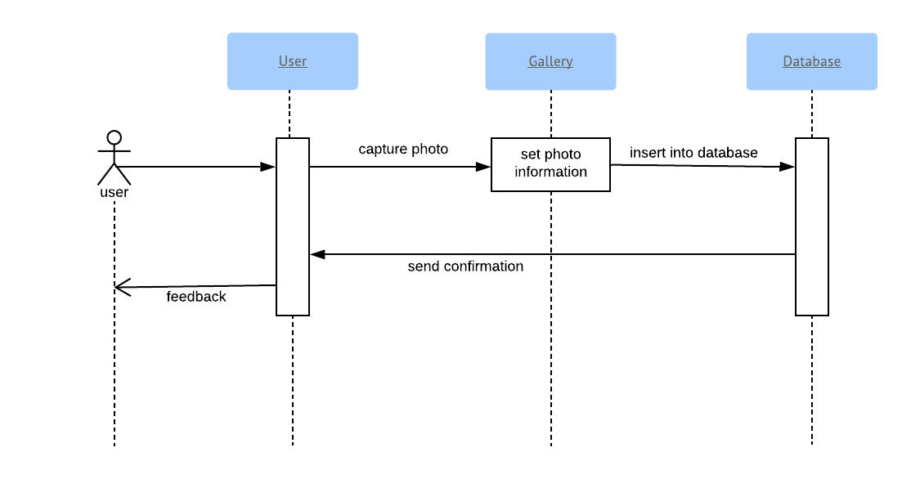

#### 8.2.6 Sequence diagram of Update Profile

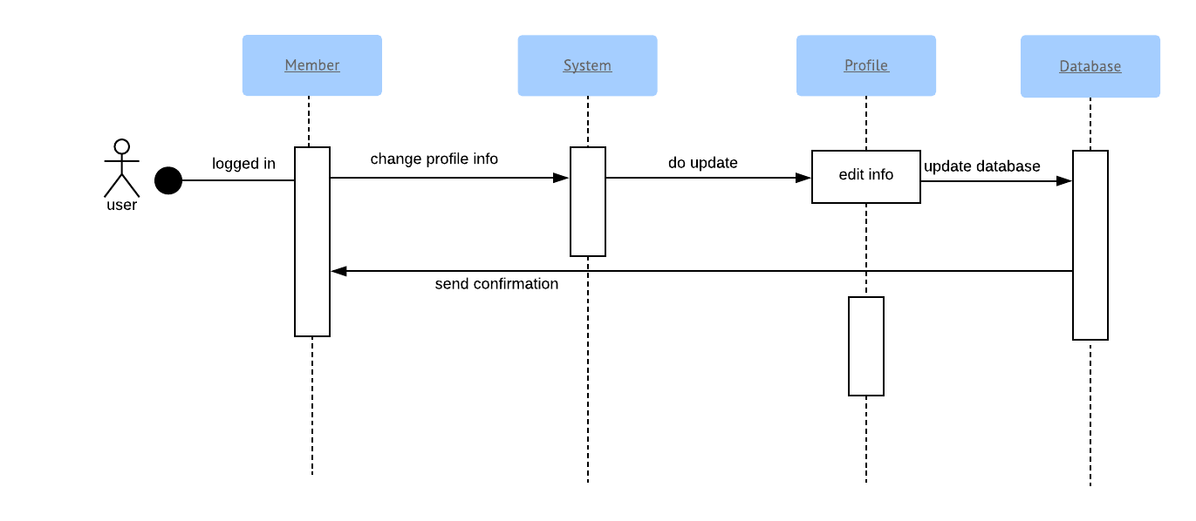

**Chapter 9: Conclusion**

We are very pleased to successfully draw the conclusion of software requirement specification and analysis of our software project - Camera Synchronization an Android App.

We hope our report will be able to convey a clear picture of our system to all stakeholders, and act as a basis throughout full development cycle. We have tried our best to make a complete, practical, consistent and unambiguous specifications; which helped us tremendously in our understanding of the scope and detailed process of software requirement engineering process. We think that this report has been written in an easy-to-read way as well as with full information required to have a good concept over the idea. We sincerely hope this document will be able to satisfy the goals all stakeholders expect from it. We hope that any reader going through this document can easily understand the whole idea behind the Camera Synchronization Android App. Hopefully, it will be an easy path-showing document for the implementation of the application!